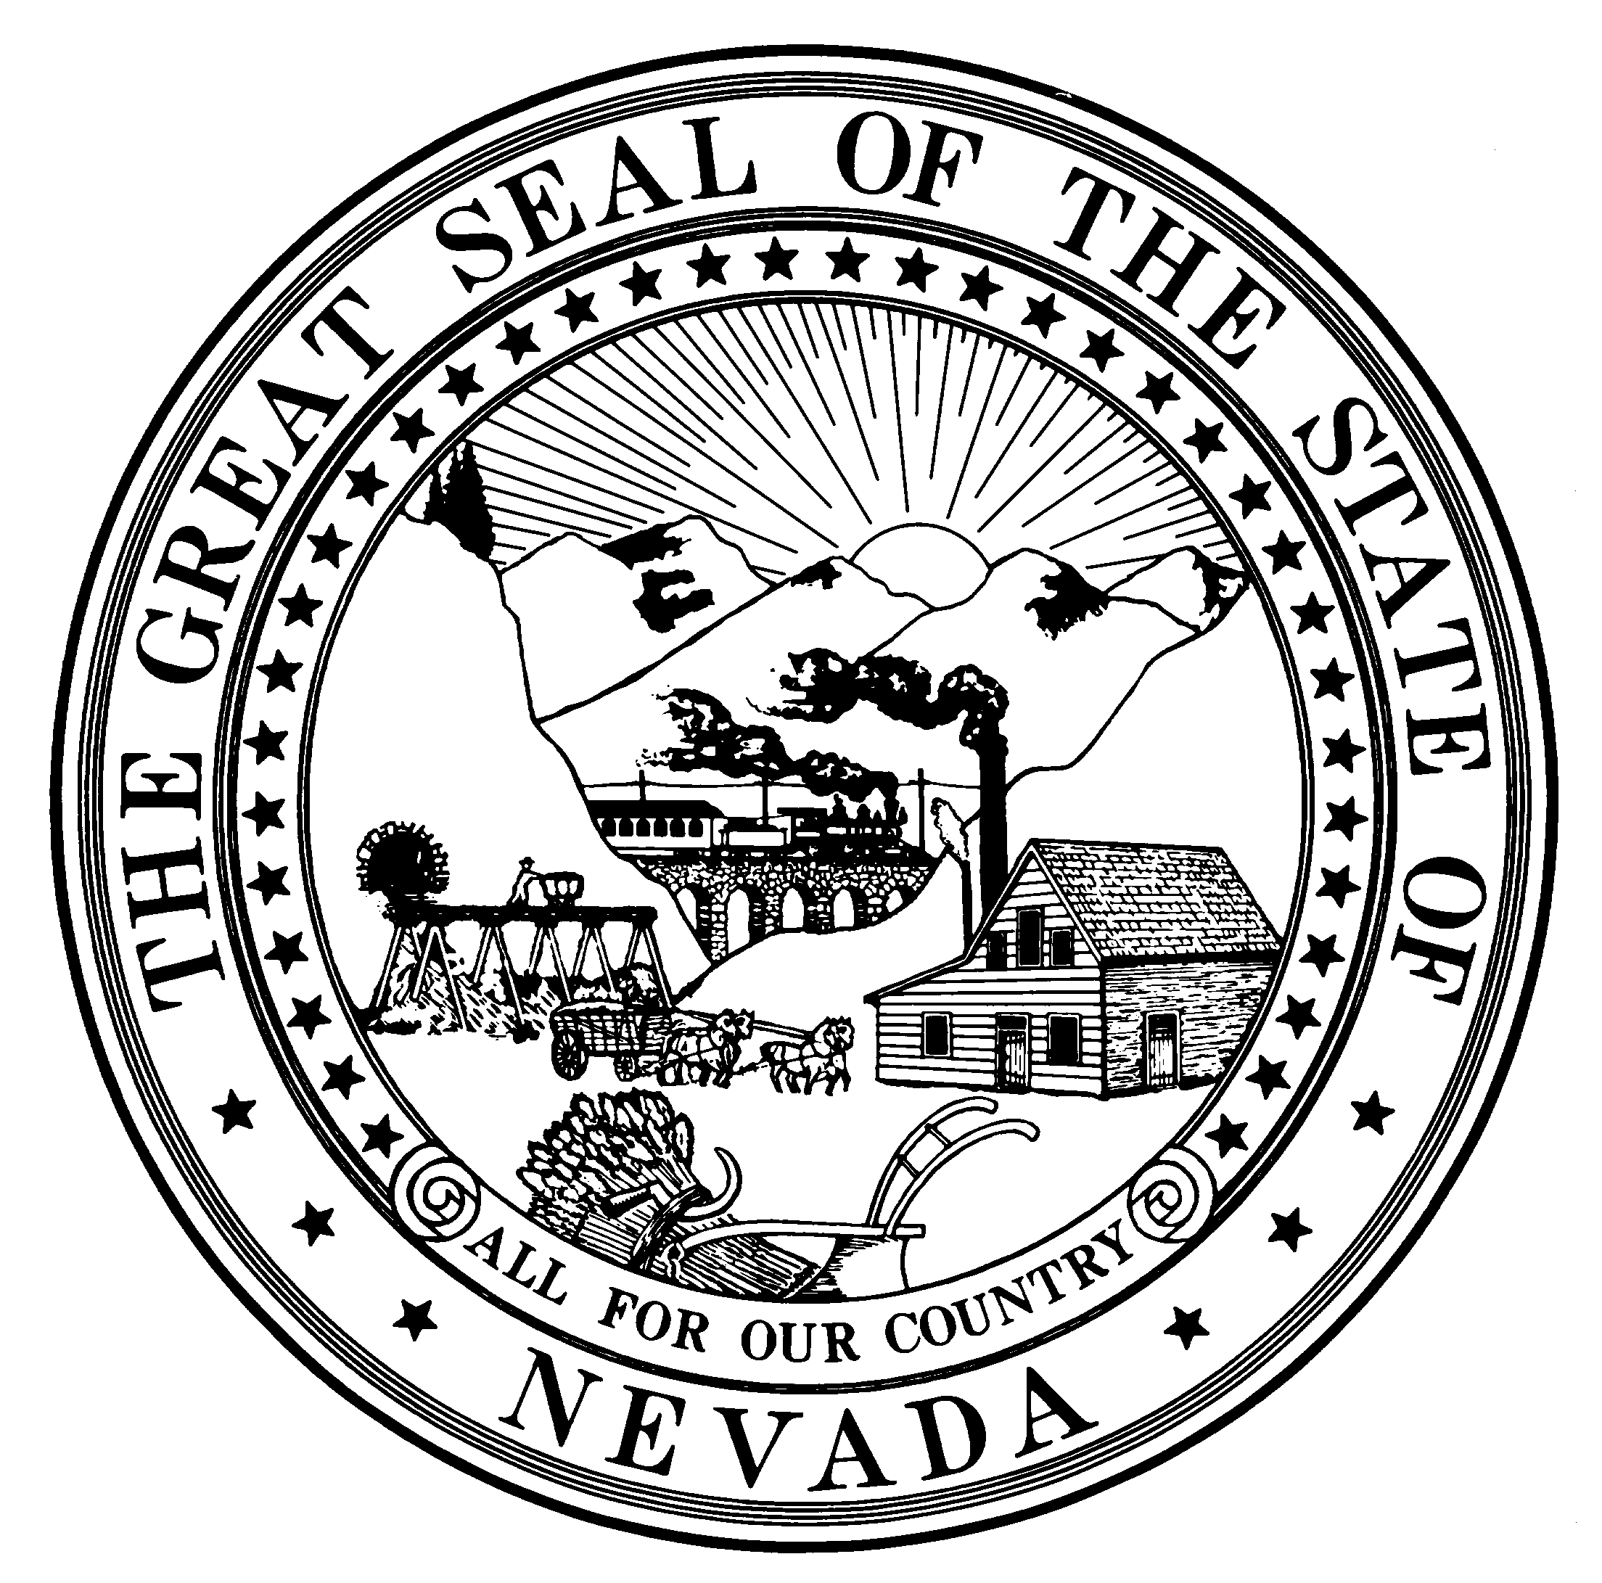

MEMBERS:

Ronald Hedger, D.O

President NEVADA STATE
Ricardo Almaguer, D.O BOARD OF OSTEOPATHIC MEDICINE
Vice President 901 American Pacific, Suite 180
James Anthony, D.O., J.D., M.B.A Henderson, NV 89014
Secretary/Treasurer Ph. 702-732-2147 Fax: 702-732-2079
Thomas Naegele, D.O. www.bom.nv.gov
Member
Samir Pancholi, D.O. November 7, 2026 Barbara Longo, CMBI
Member Executive Director
S. Paul Edwards, Esq.
Public Member
Nicole Cavenagh, Ph.D. Steven Ray, CMBI
Public Member Chief of Enforcement

What is a D.O.?
Only two kinds of physicians are qualified to be licensed for the unlimited practice of medicine in all 50 states: those holding the D.O., or Doctor of Osteopathic Medicine degree, and those who have earned the M.D., or medical doctor degree,

While D.O.s and M.D.s are very similar in many ways, it is the addition and uniqueness of training and the approach that the Osteopathic Physician has with the structure, function and interrelationship to body mechanics that differentiates the D.O. from the M.D. It is for this reason that it is essential that there is a separate and distinct professional licensing board for osteopathic physicians.

How are D.O.s and M.D.s the same?
Their educational requirements are the same:
- Both have a four-year undergraduate degree
- Both have completed four years of basic medical education
- Both have completed a residency program for their specialty (three to six years)
- Both have the same specialties (for example family practice, ob/gyn, internal medicine, orthopedic surgery, psychiatry, etc.)
- Both are fully licensed to diagnose illness, perform surgery, and prescribe medicine
- Both practice in fully accredited and licensed hospitals and medical centers

How are D.O.s and M.D.s different?
- The D.O. receives more training in the musculo-skeletal system and its interrelationship to proper structure and function of the body.
- D.Os help their patients develop attitudes and lifestyles that do not just fight illness, but prevent it by giving special attention to how the body’s nerves, muscles, bones, and organs work together to influence health.
- Some D.O.’s specialize in osteopathic manipulative treatment, using their hands to diagnose and treat injury and illness, encouraging the body’s natural ability to heal itself.
- Structure and function are reciprocally interrelated and rational therapy is based upon an understanding of these basic principles of the body unit, self regulation, and the interrelationship of structure and function.

The Nevada State Board of Osteopathic Medicine (NSBOM) licenses and disciplines Osteopathic Physicians (D.O.s) and Physician Assistants (P.A.s) for the State of Nevada. We exist to protect and serve the residents of the state of Nevada. The NSBOM was established in 1925 and the first Board meeting was held that same year with two board members attending. In 1977, Nevada Legislature added NRS chapter 633 incorporating the prior statutes and enacting additional statutory mandates. Included in the law are measures that define the qualifications of Board members, the licensing requirements, the content of reports the Board must provide to members of the Legislature every other year as well as steps the Board must follow to suspend or revoke the license of a D. O.

The Board currently licenses more than 1,000 1200 D.O.s and 67 100 P.A.s. The average number of complaints the Board addresses annually is 144, and the number of settlement agreements in which the Board enters into is approximately 30 15 a year. One Board member is assigned to investigate and rule on each complaint. The Board staff assists by obtaining the necessary documents required for the Board member to make a decision.

Dr. Joe Heck, a United States Congressman and former Nevada state senator, is a D.O. , so is Dr. Lawrence Sands, the current Chief Health Officer of the Southern Nevada Health District. Over the years, a number of Chiefs of Staff for various hospitals throughout Nevada have been osteopathic physicians.

